**DETOX DIET AND FOODS TO EAT AND AVOID**

Bored of exercising and waking up early and jog around? Here’s a simple solution to improve eating habits and leading towards a healthy life. A simple Detox diet to follow and walk happily.

**Seriously, No exercise?**

If you can follow up a simple Detox diet meal plan, you need not to pain your muscles to stay healthy. After all, the early diseases we catch are the results of our bad eating habits.

**What is Detox diet?**

A diet consisting of high fibre food and low saturated fats is detox food. To flush out extra oils and fats deposits from kidneys and liver, detox diet plan is recommended. In a way, it relaxes the inner organs like they are on a holiday or a spa treatment. A detox diet plan is a way of detoxification.

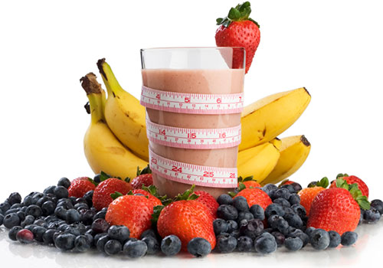

**Detoxification..? What is that?**

Detoxification is when our body is unable to kill or digest more toxicity and a natural external process is therefore performed to cleanse the body and re-energise the weak cells to carry out their respective operations in the body. Supported by a healthy detox diet meal plan and gluten-free, detoxification can create miracles!

**How is Detox diet and weight loss related?**

Detox diet and weight loss are complementary to each other. Detox diet food provides body nutrition and helps achieve body goals in around 2 months if done properly. Weight loss follows. If you take care of things you eat, your digestive tract will remain healthy and work efficiently without causing further problems. Also, it will close the gates for several hard-to-cure diseases to enter!

We now know the benefits, but what exactly needs to be done?

**Healthy brain produces peaceful thoughts**

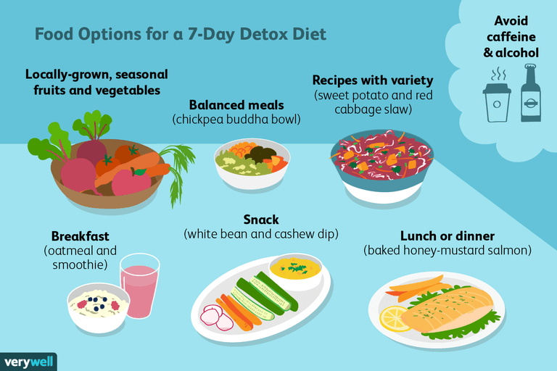Detox diet recipes are not hard to follow once you get used to it. Fuel up the motivation! you take a planned detox diet and weight loss will follow as a bonus! What do you need? Prepare a detox diet menu and add detox diet food in the list keeping in mind your immunity and body endurance.

**Detox diet chart**

A Detox diet chart is a must to proceed with:

* WATER must be a priority.

Two-third of our body is made up of water, its deficiency can lead to serious health problems like dehydration, constipation, etc. Drink at least 7-8 glasses daily.

* Fluids help remove toxins faster.

Healthy drinks like green tea and fruit juices (without sweeteners) prove to provide a healthy immune system by taking away minute toxic substances that stick to walls of kidneys. Two tablespoons of Chia seeds mixed with water everyday reduce chances of heart attack and stroke. Avoid intake of caffeine as possible!

* Gluten-free diet is suggested.

Benefits a gluten diet contain is not necessarily required by our body. But to some, it might cause severe problems such as coeliac disease, wheat allergy and more. So why not opt a gluten-free diet to armour our body from additional errors.

* Fruits and vegetables have topped the detox diet chart every single time.

They are high in nutritional value and form a protective shield around the body against harmful virus and bacteria. Except banana and excess of mango, go and pick fruit variants!

On the same hand, vegetables have a higher content of fibre that nourishes body and soothes the digestive tissues like a medicine.

A perfect detox diet menu is prepared by your own body! Don’t push unnecessarily to extents your body couldn’t handle. Make some amendments in your detox diet recipes according to likes and tolerance. A preferable detox diet menu is what makes you healthy, not weak.

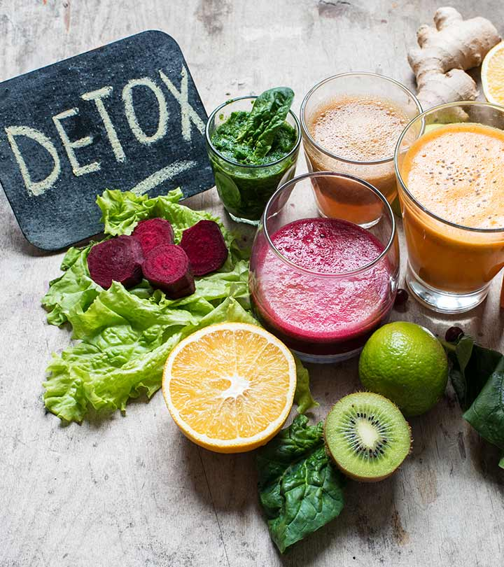

**But, what is a gluten-free diet and what does a gluten-free diet helps in?**

Gluten is composites of protein found mostly in whole grains like wheat, barley, rye, oats. A gluten-free diet consists of rice, corn, potato, soy, beans etc. said to protect from various gluten-borne diseases.

Also, gluten-free food helps in detoxification to some extent and promotes detox diet meal plan. Set your feet together and relax! You just need to have a good Detox diet plan ready.